**Predicting Malignant and Benign Tumors: XGBoost Classification Tutorial**

**1. Introduction**

**Objective:**  
This tutorial’s aim is to demonstrate how to classify malignant vs. benign breast tumors using XGBoost classifier. We take you through some core steps, such as data exploration, data preprocessing tasks , model training and performance evaluation and provide visualizations to understand the content more easily and close to best practices in machine learning.

**Why XGBoost?**

Extreme Gradient Boosting (XGBoost) is an ensemble method which has always taken a top 1 position in the majority of popular machine learning competitions. It iteratively builds a series of weak learners (decision trees), fixing errors of previous trees, and find the right balance between speed and robust performance. This makes this a fantastic selection for medical classification tasks that might be critically depending on each accuracy and interpretability. (Chen, 2016)

**2. Dataset Overview**

**Dataset:** Breast Cancer Wisconsin (Diagnostic) from scikit-learn.

* **Features (30 total):**
  + Examples: mean radius, mean perimeter, mean texture, mean concavity, etc.
  + Each feature quantifies various cell nucleus characteristics derived from digitized images.
* **Target Variable:**
  + 0 = Malignant (212 samples in the dataset)
  + 1 = Benign (357 samples)

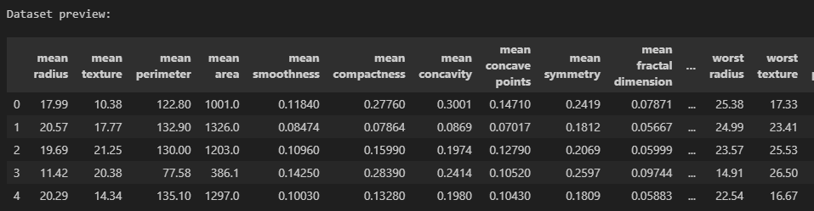**Data Preview:**

**Class Distribution:**

* **Malignant:** 212 samples
* **Benign:** 357 samples

This slight imbalance highlights the importance of robust metrics (like precision, recall, F1-score) and not just accuracy.

**3. Data Preparation and Preprocessing**

1. **Train-Test Split (80:20):**
   * **Stratified** to maintain class proportions.
   * Training set size: 455 records
   * Test set size: 114 records
2. **Feature Scaling:**
   * **StandardScaler** was used to normalize each feature.
   * Scaling ensures that features have comparable ranges, which often helps tree-based ensembles converge faster and handle diverse feature magnitudes more effectively.

**Why Scale for XGBoost?**  
Even though decision trees can handle unscaled data, scaling can still stabilize optimization steps and sometimes improve performance—especially when advanced regularization is involved. (Chen, 2016)

## ****4. Model: XGBoost Classifier****

### ****4.1 How XGBoost Works****

One of the ensemble learning technique is ‘XGBoost’ which is based on decision trees. In contrast to individual Decision Trees that predict independently, XGBoost constructs a series of trees and each new tree adjusts the previous ones’ mistakes. It is based on the principles of gradient boosting where the model tunes trees in an attempt to minimize the loss function (such as log loss) by training trees on the residual errors of previously trained models. (Chen, 2016)

Here’s how it works step-by-step:

1. **Initial Model Creation** – The model starts with a weak learner (usually a simple decision tree) that makes initial predictions.
2. **Gradient Calculation** – It computes the difference between the predicted and actual values (residual error).
3. **Boosting Step** – A new tree is added to predict these residual errors, essentially reducing the overall error.
4. **Tree Pruning and Regularization** – To avoid overfitting, XGBoost uses techniques like:
   * **L1 Regularization (Lasso)** – Penalizes the absolute value of coefficients to encourage sparsity.
   * **L2 Regularization (Ridge)** – Penalizes the square of coefficients to prevent overly large weights.
5. **Learning Rate and Shrinkage** – The contribution of each tree is scaled down by a learning rate to improve generalization.

### ****4.2 Why XGBoost is Powerful****

* **Handling Complex Data** – XGBoost handles both numerical and categorical data effectively.
* **Feature Interactions** – Boosting allows the model to capture complex interactions between features.
* **Handling Missing Values** – XGBoost can internally handle missing data, deciding the best path to take for a missing feature.
* **Parallel Processing** – XGBoost is designed to handle large datasets efficiently by leveraging multi-threading and GPU acceleration. (Chen, 2016)

### ****4.3 Training Procedure****

1. 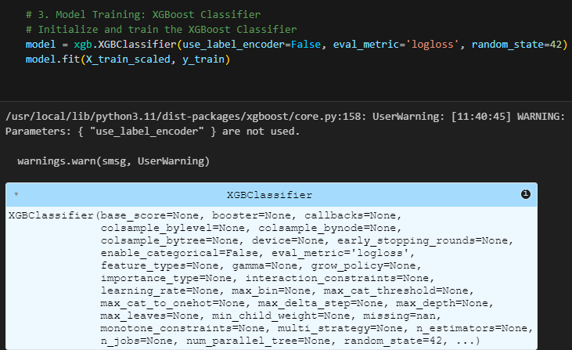**Model Initialization**  
   We initialize the model with eval_metric='logloss' to track performance based on the logarithmic loss function:
2. **Training the Model**  
   We train the model using the fit() function on the scaled training data:
   * The model learns patterns from the training set.
   * Gradient boosting refines the model by reducing the error at each iteration.
3. 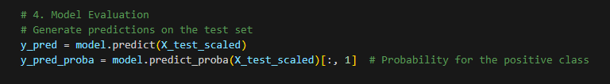**Making Predictions**  
   The model generates predictions using:
   * y_pred gives class labels (0 = malignant, 1 = benign).
   * y_pred_proba gives the predicted probability for class 1 (benign).

#### **4.4 Why XGBoost Was Effective**

* **Gradient boosting** allows the model to adapt to complex, non-linear patterns.
* **Regularization** prevents overfitting by reducing complexity.
* The model handles both small and large datasets efficiently using parallel processing.
* **Feature importance analysis** helps explain why the model makes certain predictions, improving interpretability for medical decision-making. (Chen, 2016)

The structured boosting approach results in a model with 95% accuracy on the test set and an extremely good ROC AUC score of 0.992, close to perfect separation between benign and malignant cases.

**5. Performance Evaluation**

**5.1 Classification Report**

* **Precision (0.95)**: Of all tumors predicted malignant, 95% were truly malignant.
* **Recall (0.90)** for malignant: The model identified 90% of malignant cases correctly.
* **F1-score** of 0.93 for malignant indicates a strong balance between precision and recall.

**5.2 Confusion Matrix**

|  |  |  |
| --- | --- | --- |
|  | **Predicted: Malignant** | **Predicted: Benign** |
| **True: Malignant (0)** | 38 | 4 |
| **True: Benign (1)** | 2 | 70 |

**Analysis:**

* The model **correctly** identified 38 malignant tumors out of 42, missing 4 (false negatives).
* The model **correctly** identified 70 benign tumors out of 72, with 2 false positives.

**Teaching Insight:**  
A small number of false negatives is critical in a medical context—missing malignant tumors can have severe consequences. We might adjust thresholds or emphasize recall if minimizing false negatives is paramount.

**6. Visual Analysis**

**6.1 Confusion Matrix Heatmap**

A color-coded confusion matrix offers a quick overview of correct vs. incorrect predictions. Darker squares along the diagonal indicate more correct classifications. The mild off-diagonal numbers (4 and 2) represent misclassifications. 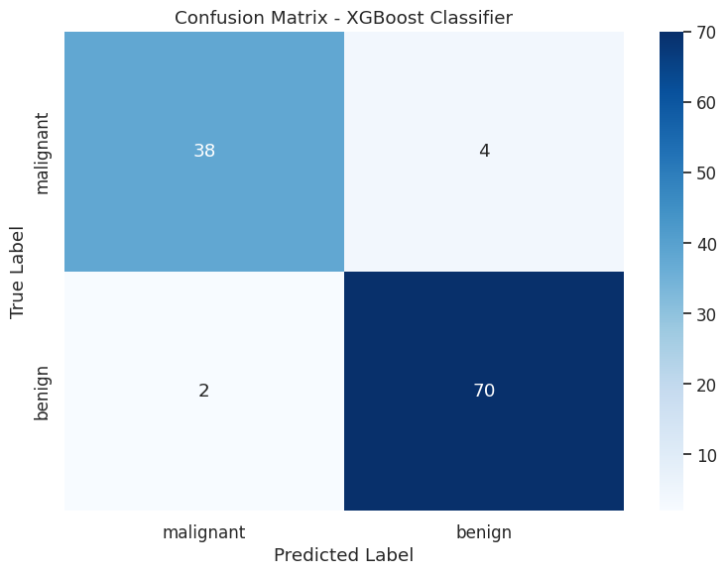

**6.2 ROC Curve and AUC**

**ROC AUC Score:** 0.992

* The ROC curve plots the **True Positive Rate (TPR)** against the **False Positive Rate (FPR)** at various probability thresholds.
* An area under the curve (AUC) of 0.992 is exceptionally high, indicating the model distinguishes malignant from benign almost perfectly across thresholds. 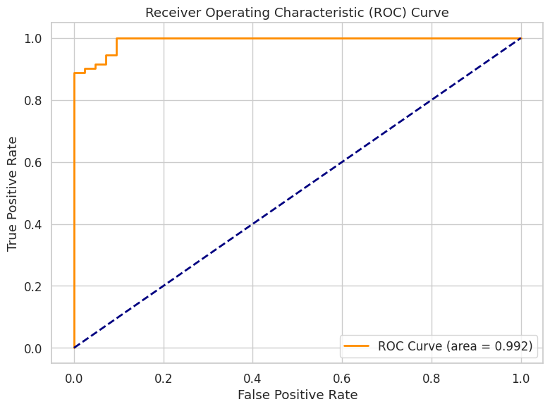

**6.3 Feature Importance**

The bar chart reveals which features contributed most to the decision-making process:

* **worst radius** and **worst perimeter** dominate, indicating that tumor size/shape variability is highly predictive.
* Features like **mean concave points** and **worst concavity** also show significance, consistent with known diagnostic factors in breast cancer.

**Teaching Point:** Understanding feature importance helps in medical contexts because it highlights which physical tumor characteristics most strongly influence the classification.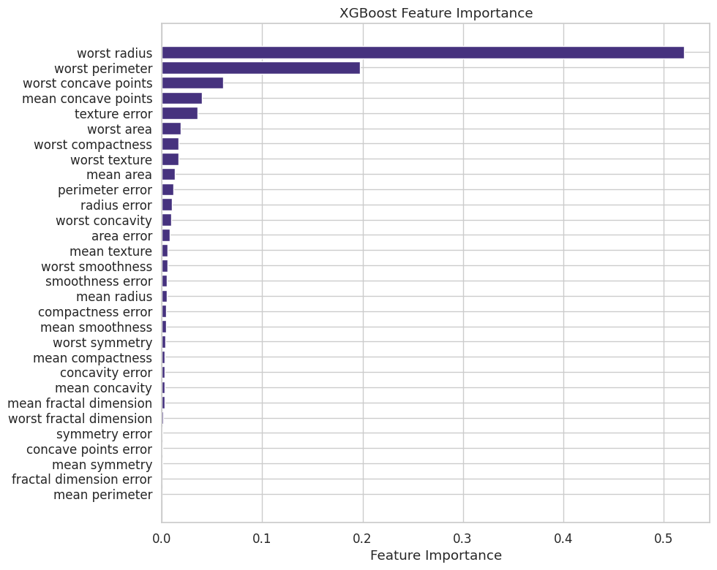

**6.4 Predicted Probability Distribution**

This histogram shows the probability that each sample is malignant. We see:

* A large cluster near 0.0 (predicted benign).
* Another cluster near 1.0 (predicted malignant).

Very few data points fall in the midrange (around 0.5), indicating confident predictions for most samples.

**7. Interpretation and Discussion**

1. **High Accuracy with Some Caveats**
   * 95% accuracy is strong, but misclassifications still exist. In a medical setting, we might prioritize **high recall** to reduce false negatives (missing malignant cases).
2. **Threshold Tuning**
   * If reducing false negatives is a priority, we can adjust the probability threshold downward to classify a tumor as malignant more conservatively.
3. **Potential Overfitting?**
   * With a relatively small dataset, it’s prudent to monitor overfitting. Tools like cross-validation or grid search can further validate this model’s stability.

**8. Conclusions and Future Work**

**Key Takeaways**

1. **XGBoost** is highly effective for this classification task, reaching **0.95 accuracy** and **0.992 AUC**, which is outstanding for a medical application.
2. **Feature Importance** analysis aligns with known medical insights: size and shape metrics are highly indicative of malignancy.
3. **Threshold Adjustments** can be explored to prioritize fewer false negatives in clinical practice.

**Future Directions**

* **Hyperparameter Tuning:** Perform a grid search or randomized search over XGBoost parameters (e.g., n_estimators, max_depth, learning_rate) to refine performance.
* **Ensemble Comparisons:** Compare XGBoost with other advanced classifiers (e.g., LightGBM, CatBoost) or even neural networks.
* **Explainable AI Tools:** Use SHAP or LIME to provide instance-level explanations, important for clinical contexts. (Chen, 2016)

**9. References**

1. Chen, T., & Guestrin, C. (2016). *XGBoost: A Scalable Tree Boosting System.* In *Proceedings of the 22nd ACM SIGKDD International Conference on Knowledge Discovery and Data Mining* (pp. 785–794).
2. UCI Machine Learning Repository: [Breast Cancer Wisconsin (Diagnostic) Data Set](https://archive.ics.uci.edu/ml/datasets/Breast+Cancer+Wisconsin+(Diagnostic)).
3. Scikit-learn documentation: Breast Cancer Dataset.

**10. Accessibility and Reproducibility**

* **Colorblind-Friendly Palettes**: Chosen for confusion matrices and plots.
* **Screen Reader Compatibility**: Clear headings, descriptive text.
* **Open-Source Code**: Provided in a Jupyter Notebook with instructions for installation and replication.
* **GitHub Repository**: (Link) includes a README.md, LICENSE, and the .ipynb file for immediate usage.